**Is India a Trade Colony of China ?**

***Nishad Nagpure***

***MSc 2021, IGIDR***

***Professor – C. Veeramani Sir***

***Date : 26-10-2022***

***Acknowledgement***

***I would like to acknowledge and give my warmest thanks to my supervisor Prof. C. Veeramani sir who made this work possible and provided very insightfull knowledge and wisdom during this research project. His guidance and advice has carried through all stages of this research paper.***

**Background**

In the time of globalisation, a suprising change in the people’s viewpoint of international trade has brought up a fierry of economic decisions that has surprised lots of economist and the scholars of the subject.US President Donald Trump using the soft power of his position and his country even if not completely but in major proportion has demonized international trade. International Trade being the medium of gaining geo-political brownie points has gain popularity and voters mass attention.

In this paper we are going to analyze the bilateral trade relation of India and China, from the prism of other developing nations which have substantial amount of trade with China.

What is a trade colony ?

To put it in a perspective let us take an example of trade between India and Britain during british colonialism, India exporting raw materials and importing finished goods, what was India’s gross value addition to a product which was imported in a ready to use condition being a labour abundant country.

**Abstract / Introduction**

India’s exports to China have risen over the last few years even as its imports have fallen. But a closer look riveals unequal bilateral trade. Trade numbers between 2014-15 and 2019-20 show that export of low-value raw materials and import of high-value manufactured goods has characterised India’s trade relationship with China.

If we look at the Indian history of colonialism under Britain, it is well known that until the 17th century, India was a dominant player in global trade. India was a big exporter of finished goods, particularly textiles.

India and other colonies were producing cotton, which was then going to Britain and they were converting this into textiles, which were coming right back to India. That is how Gandhi started his Swadeshi movement saying that we will make our own cloth. This is the essence of colonialism.

**Data Collection and Country Selection**

So, to analyse the question quantatively, I proposed a ordinary least square model which required a substantial amount of data and proper variables of interest for satisfying its rigourous and lengthy assumptions.

The countries selected should have resembling features with Indian economy on some level. As India is a developing economy, with bilateral trade relations with China, so the selected countries must have these features atleast.

1. Argentina
2. Bangladesh
3. Brazil
4. Egypt
5. India
6. Iran
7. Indonesia
8. Philippines
9. Vietnam
10. Pakistan

**Argentina**

A Latin Amerian nation with developing economy who faced bankruptcy at various point in time has gdp per capita of approximately $ 8000 today and exports very much agrarian products to the world and China.

Export products includes :

1. Corn
2. Wheat
3. Soyabean
4. Soyabean Meal
5. Frozen Wheat

**Bangladesh**

An Islamic Country east of India came to existence in 1971 after India defeated Islamic army of Pakistan another Islamic Republic west of India today has gdp per capita of $ 2270 and exports clothing related proucts and raw material to the world and China.

Export products includes :

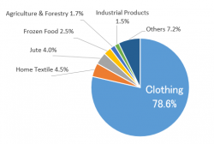

**Brazil**

Another Latin American country known for its Football team and Amazon Forest having $ 6814 per capita income exports products such as Petroleum Crude oil, Iron ore, Soyabean, etc.

Export product includes :

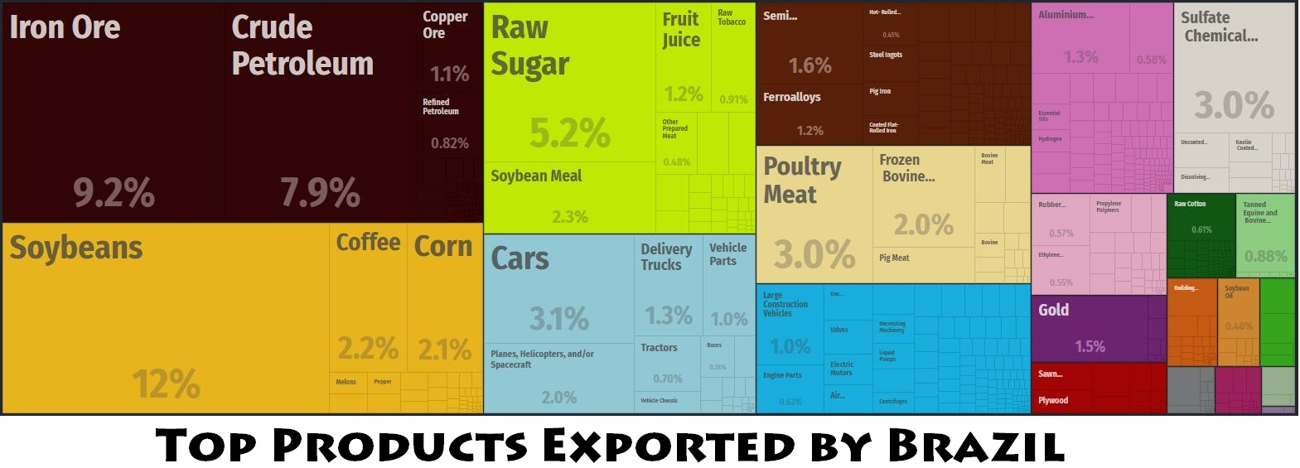

**Egypt**

Arab Islamic Republic of Egypt north african meditterean country known for its pyramids and strict military rule has per capita income of $ 3500, has China its 3rd largest trading partner.

**India**

The Republic of India situated south of asian continent covered by himalayas has gdp per capita of $ 2500. The main exporting products are petroleum products, engineering anxillaries and other raw material.

**Indonesia**

A Indian ocena island with 4th largest population in the world, known for its tourism industry and other agrarian products, it has China at its largest trading partner with bilateral annual trade going up to $ 31783 millions.

**Islamic Republic of Iran**

The middle eastern country, highly authoritarian has gdp per capita of $ 2576. Its main exporting products include dry fruits, dates, crude oil. This Islamic nation also has China as its largest trading partner with bilateral trade value goin upto $ 9218 million.

**Nigeria**

This center to west african nation with highly unstable government and religious fanatism has gdp per capita of $ 2097. It also has China as its largest trading partner with trade value above of $ 15947 million.

**Philippines**

This east asian country in Indo-Pacific region has gdp per capita of $ 3301 and also has China as its 2nd largest trading partner.

**Vietnam**

This east asian nation bordering China in the north has been known for its cheap labour and economies of scale with gdp per capita $ 3694 also has China as its largest trading partner.

**Pakistan**

This middle eastern nation looking at the verge of economic collapse is constantly under the military establishment/ rule with very fragile civilian government and completely compromised judiciary system has gdp per capita of $ 1573 one of the worst in its region. The country exports raw material products related to agrarian economy and some value of textile to the world.

**Methodology**

I collected the trade data of 11 countries including India from a time period of 2009 to 2020 with Independent variables being gdp per capita income of each country at each time period, total export of raw material to china , total import of finished goods from china, total export of finished goods to china , total import of raw materials from china , total imports from china, total exports to china.

Gdp per capita : ***gdp_per_capita***

Total export of raw material to china : ***raw_to_china***

total import of finished goods from china : ***fin_from_china***

total export of finished goods to china : ***fin_to_china***

total import of raw materials from china : ***raw_from_china***

total imports from china : ***from_china***

total exports to china : ***to_china***

Model 1 :

**ln(to_china)** = ***α + βj * (gdp_per_capita) + β2,I + β3,j  + ϴi,j * dummy(ln (raw_to_china)) + €I,j * β3,j  *dummy (ln(raw_to_china)) + ℇ***

**ln(to_china)** = ***α + βj * (gdp_per_capita) + β2,I + β3,j  + ϴi,j * dummy(ln (fin_to_china)) + €I,j * β3,j  *dummy (ln(fin_to_china)) + ℇ***

Model 2 :

**ln(from_china)** = ***α + βj * (gdp_per_capita) + β2,I + β3,j  + ϴi,j * dummy(ln (raw_from_china)) + €I,j * β3,j  *dummy (ln(raw_from_china)) + ℇ***

**ln(from_china)** = ***α + βj * (gdp_per_capita) + β2,I + β3,j  + ϴi,j * dummy(ln (fin_from_china)) + €I,j * β3,j  *dummy (ln(fin_from_china)) + ℇ***

The variable of most interest to use for the pupose of this paper is ***€I,j * β3,j*** which will convey use the trade pattern of other countries with China.

**Null Hypothesis : All other countries have different trading pattern with China than India.**

**Alternative Hypothesis : Majority of countries have similar trading pattern with China and India is not exception.**

**Results**

Model 1 : when (we are looking for exports of raw material from the countries of interest)

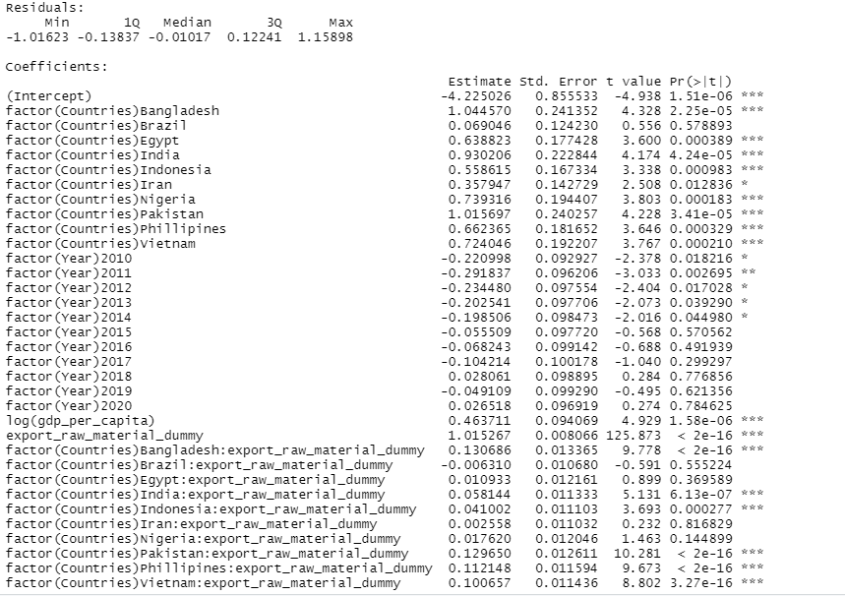

Model 1 : ( when we are looking for export of finished goods from countries of interest)

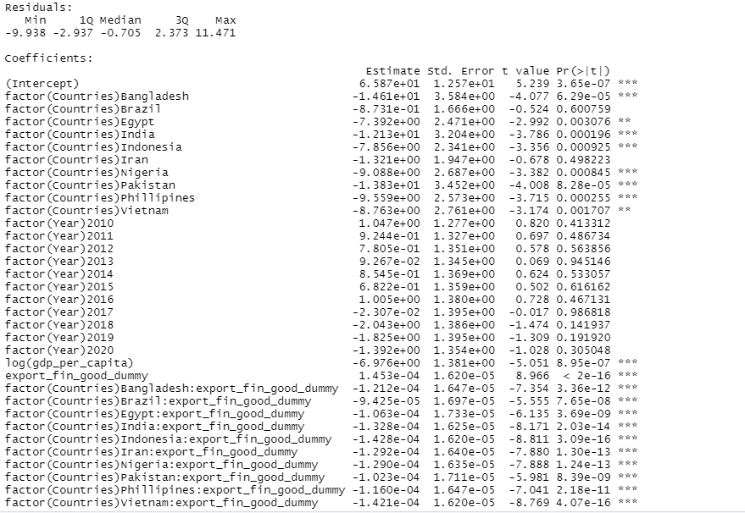

Well , clearly we can see that it is not specifically India who exhibits this pattern of trade where its exports raw material and imports finished goods from china but also other developing nations having resembling economies to India also exhibits same pattern of trade.

Where, the countries exporting raw material to china has positive coefficient of estimate and on the same line if we see in model-1 second chart, countries exporting finished goods to china has negative correlation with its total exports to china whereas if we see trade with china for these countries has increased by many folds from the past decade and is still in immense growth potential.

Model 2 : (when we are looking for imports of raw materials by interested countries from china)

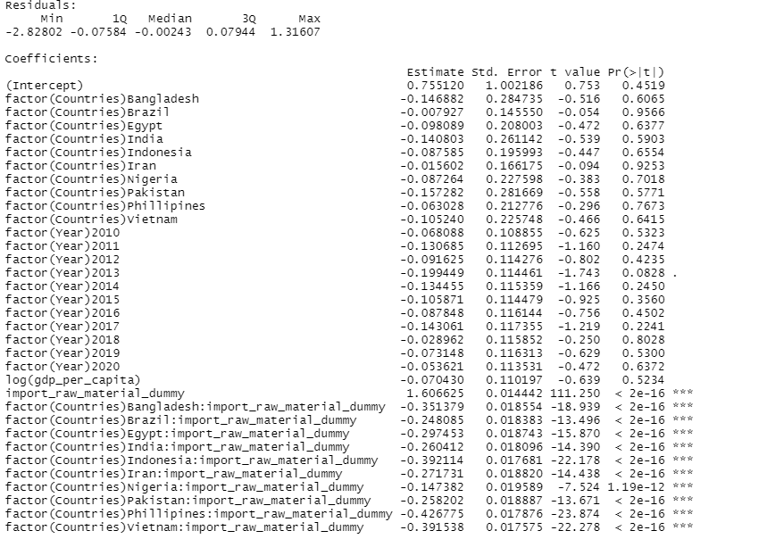

We can see that import of raw material from China by various countries has negative coefficient of estimator which tells us that as the trade with China has increased China has exported less and less amount of raw material to all the developing countries that we have included in our model.

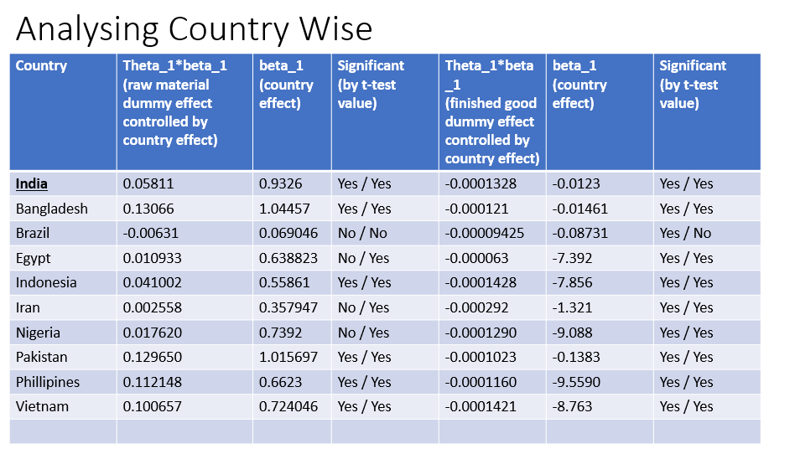

**India – China Bilateral Trade**

India’s import products from China

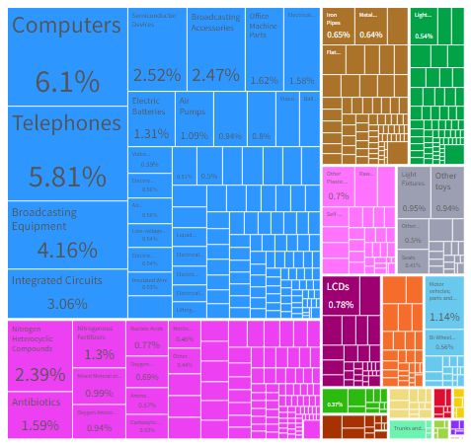

India’s export product to China included :

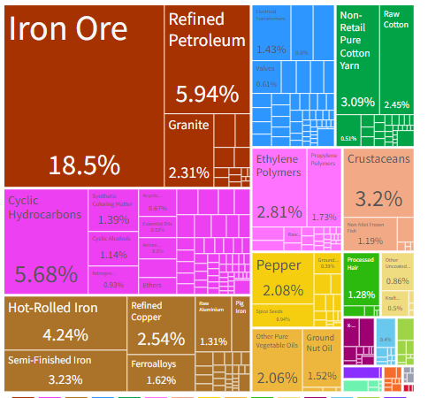

**China – Brazil Bilateral Trade**

Brazils export to China includes :

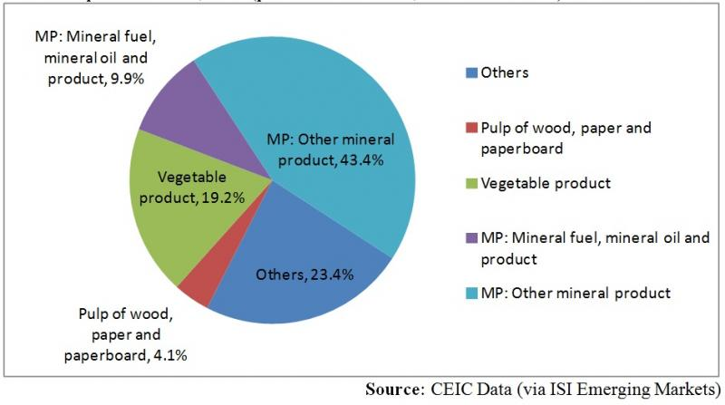

**Bangladesh – China Bilateral Trade**

China’s export products to Bangladesh includes :

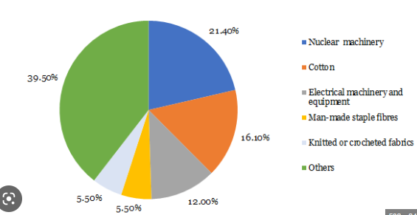

Bangladesh’s export product to china includes :

1. Jute
2. Yarn
3. Frozen Fish
4. Apparels
5. Fabric

**Indonesia – China Bilateral Trade**

We can clearly observe that total import of finished goods from Indonesia is many folds more than the imports of Raw material which is in line with our hypothesis.

Import products includes :

1. Furniture
2. Pre – Fabricated Buildings
3. Distillation Products

Export products include :

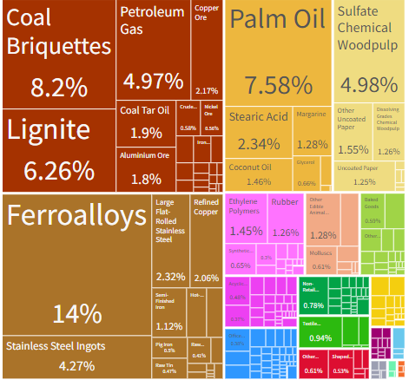

**Philippines – China Bilateral Trade**

Imported Products include :

1. Electrical and Electronic equipments
2. Machinery
3. Nuclear reactor
4. Boilers

Again the pattern of trade remains same where philippines import finished goods from China and exports raw material which in turn meets with gross value addition done by the big giant manufacturing plants of China and is exported back to Philippines.

**Vietnam – China Bilateral Trade**

Import products includes :

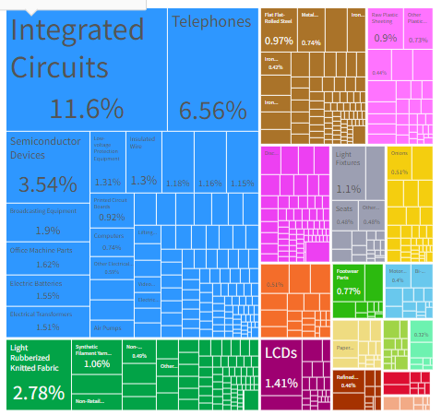

Vietnam’s export products to China includes :

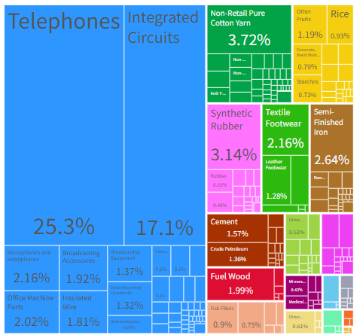

**Pakistan - China Bilateral Trade**

Pakistan’s import products from China includes :

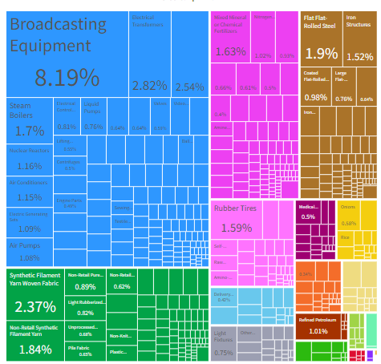

Pakistan’s export products to China includes :

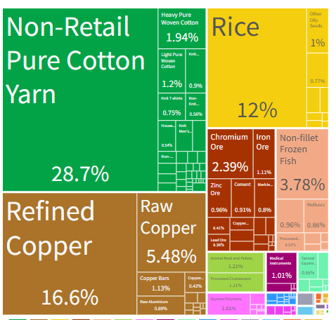

**Conclusion**

While analyze above graphs and look at the results we obtained from our regresssio analysis, we can pretty much say it with confidence that all developing economies irrespective of India has same bilateral trade pattern with China, Where they export raw material from China and import finished goods.

The main reason behind this can be the manufacturing muscle power and advantage that China enjoys at the moment on the world stage, the country is known as the engine of growth on the world.

8 out of 11 countries satisifies our alternative hypothesis (Please visit the table again)

Therefore we do have enough evidence to reject our null hypothesis.

**References –**

1. WITS data archive – [www.wits/worldbank/org](http://www.wits/worldbank/org)
2. Trading Economies – www.tradingeconomies.com